**AutoSys** is an automated job control system

for scheduling, monitoring, and reporting.

These jobs can reside on any **AutoSys**-configured machine that is attached to a network.

It consists of 3 tier **architecture.**

**main components are** Event Server, Agent Server, and an Event Processor.

Autosys conists

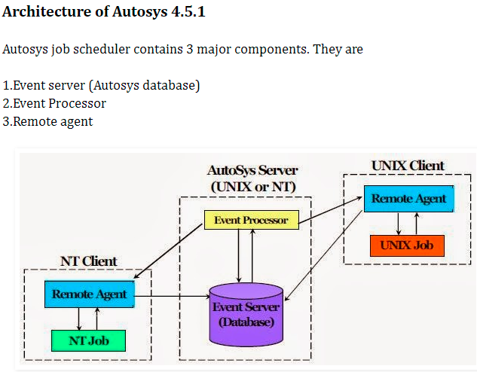

Each job definition contains a variety of qualifying attributes, including the conditions specifying when and where a job should be run.

1. **Explain On_ice In Autosys? (Important Autosys Interview Questions )**

**Answer :**

This job is removed from all conditions and logic, but is still defined. Operationally, this condition is like deactivating the job. It will remain on ice until it receives the JOB_OFF_ICE event.

SQL :-

How to delete the duplicate rows ?

Ans . Using Group by , (b) Using Row_number WTE clause (c)

INFORMATICA scenarios :-

1. Loading UNIQUE and DUPLICATE data into different target tables :-

Solution1 :

SQL override: -

Select CASE When count > 1 THEN ‘D’ ELSE ‘U’ As FLAG , E.* from (

Select col1 , col2 , count(*) as count from emp1

Group by col1 , col2 ) E ;

Solution2 : USE Aggregator Transformation + Router Transformation

Aggregator transformation: -

|  |  |  |  |  |  |  |
| --- | --- | --- | --- | --- | --- | --- |
| z | Data Type | I | O | V | Expression | Group By |
| Col1 | 5 | ✅ | ✅ |  |  | ✅ |
| Col2 | 5 | ✅ | ✅ |  |  | ✅ |
| Col3 | 5 | ✅ | ✅ |  |  | ✅ |
| Count |  |  | ✅ |  | Count(col1) |  |

Router Transformation: -